PRIBOIU INDUSTRIAL PARK

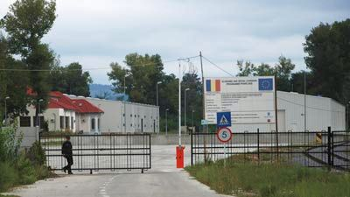

- 2014 -

Priboiu Industrial Park

Priboiu Industrial Park is located at 14 km from Targoviste, in the north of the county (on National Road DN 71 Targoviste - Sinaia), at 90 km drive away from Bucharest, 60 km from Ploiesti (on National Road DN 72 Road), 85 km from Pitesti (on National Road DN 7 Road), 80 km from the Henri Coanda International Airport (Bucharest), 350 km and 140 km drive away from Constanta and Giurgiu harbours. Moreover, Priboiu Industrial Park has its own railway network, connected to the Bucharest – Targoviste - Pietrosita railway, which represents an advantage in terms of transport of freight and raw materials.

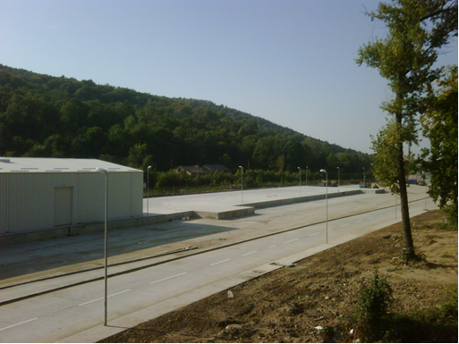
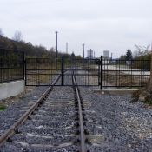

When Priboiu Industrial Park was established (through the a project developed within PHARE CES 2004-2006 Development of Regional Infrastructure Program, whose Beneficiary was the Dambovita County Council), the old Priboiu - Branesti industrial area was rehabilitated with a view to developing a modern and attractive business infrastructure. The damaged buildings were demolished, those that were still functional were restored and equipped, new buildings and interior access roads were constructed. At the same time, all utilities necessary to an industrial park were also provided.

The investment at Priboiu Industrial Park was initiated in 2007 and, at present, the Park is completed. Covering an area of 32 hectares, the Park was designed as an attractive business infrastructure in the northern part of the Dambovita County. The creation of jobs and the development of the entire area from economic and social point of views were also taken into consideration.
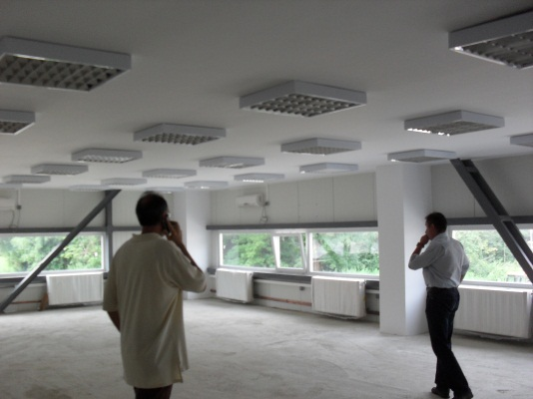
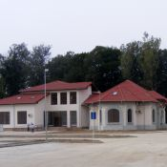

Regarding its infrastructure, Priboiu Industrial Park provides the following facilities: a paved road network, car parks, concrete platforms, an own railway, a water tank (with a capacity of 500 m³ and pumping stations), concrete platforms on which the wastewater treatment plant and the rainwater pumping station, with decanter basins, were built; a power building (a supply point of medium voltage power, a power transformer, a low voltage panel); power transformers for the medium voltage power network; a gas regulation station; car access roads and sidewalks; a metal fence in front of the Park and a perimeter fence made of concrete prefabricates; an entrance booth. The Park's utilities include: low and medium power supply networks, a street lighting network; an alarm and surveillance system; a water supply network (sprinklers, fire hydrants, drinking water); a gas supply network; a rainwater sewerage network; a wastewater sewerage network.

The Park is managed by SC Parc Industrial Priboiu SA, whose sole shareholder is Dambovita County Council.

The Park is suitable for developing activities such as: manufacturing industry, high tech industries, banking and financial, consultancy, design, research and development, as well as business administration activities.
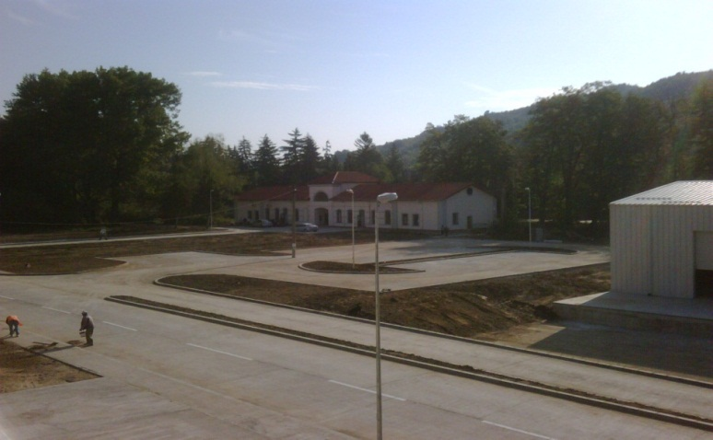

At present, 4 companies (with a total of 290 employees) work in the Priboiu Industrial Park.

Since late December 2013, a processing plant producing natural membranes has been under construction (the value of this investment being 4,500,000 Euros), which will create about 150 jobs.

Since May 2014, in the building of the Park Business Centre, in association with the University Valahia of Targoviste, a business incubator, a centre of technology transfer and IT, and a centre of scientific research in the fields of management and marketing have been working.

The Park intends to develop production activities, goods storage, and logistics service, therefore it provides the Romanian and foreign investors both adequate spaces and a number of 6 plots of land with areas ranging from 10,000 m² to 30,000 m².

PRIBOIU INDUSTRIAL PARK

Region: SOUTH MUNTENIA |  | Country: ROMANIA
Address |  | Priboiu Village, Brăneşti Commune, Dâmboviţa County, Romania
Area |  | 319,255 m²
Type |  | Industrial park
Ownership |  | Private - Dâmboviţa County Council
Administrating Company |  | S.C. Parc Industrial Priboiu S.A.
Use |  | Manufacturing industry, high tech industries, banking and financial, consultancy, design, research and development, as well as business administration activities
Operational Stage |  | Unlimited
Technical infrastructure
Power supply |  | Yes / 5.5 MVA
Gas supply |  | Yes/ 6,600 m³/hr
Water supply |  | Yes/ 1.2 l/s
Sewage system |  | Yes
Wastewater treatment plant |  | Yes
Landfill |  | Yes (Aninoasa Waste Management Centre is located at 10 km drive away)
Transport infrastructure
Acces roads to the Priboiu Industrial Park |  | Priboiu Industrial Park is located at 14 km from Targoviste, in the north of the county (on National Road DN 71 Targoviste - Sinaia), at 90 km drive away from Bucharest, 60 km from Ploiesti (on National Road DN 72 Road), 85 km from Pitesti (on National Road DN 7 Road), 80 km from the Henri Coanda International Airport (Bucharest). Moreover, Priboiu Industrial Park has its own railway network, connected to the Bucharest – Targoviste - Pietrosita railway.
Railway |  | Line no. 7, owner Romanian Railway Company, Vulcana-Pandele railway station
Airport |  | 90 km drive away from Henri Coanda International Airport (Otopeni, Bucharest)  90 km drive away from Baneasa International Airport (Bucharest)
Shipping |  | 350 km and 140 km drive away from Constanta and Giurgiu harbours
Infrastructure facilities
Telecommunications |  | Optical fibre
Roads |  | 21,300 m²
Car parks |  | 16,700 m² (for trucks and cars)
Power building |  | A supply point of medium voltage power, a power transformer, a low voltage panel
Gas supply |  | Yes
Wastewater treatment plant |  | Yes
Rainwater pumping station |  | Yes
Water tank of 500 m³ |  | It serves the fire hydrants, drinking water supply and sprinklers.
Street lighting |  | Yes
Alarm and surveillance network |  | Yes
Rainwater and domestic sewerage network |  | Yes
Land & buildings
Land area available |  | 12,000 m² (12 ha) split in 6 plots of land with areas ranging from 10,000 m² to 30,000 m²
For: | Renting | Buying | Leasing
Buildings |  | Offices - Already rent
Warehouses |  | Already rent
Others |  | Business Centre - 1,404.93 m² (ground floor and 1 floor)
Contact details
Contact person |  | Valentin Gitman, General Director
Address: |  | Aleea Sinaia, no. 60, Branesti Commune, Dambovita County, Romania
Tel: |  | +40 245 231211
Fax: |  | +40 245 231211
Email: |  | priboiuparcindustrial@yahoo.com
Website: |  | www.priboiuparcindustrial.ro

